**How To Install a Virtual Machine**

**What is a Virtual Machine?**

* A virtual machine is a digital version of a physical computer. They have all the ability of a real physical computer, except they rely on virtual resources that exist within an existing physical computer, or host. A big advantage of virtual machines is that you can run multiple computers on one single physical computer. This makes resourcing much simpler when setting up computer infrastructure as only one physical computer is required.

**Install Process**

* First download Virtual Box from VirtualBox.org, choose the correct version for your operating system. (Windows, Mac, or Linux)

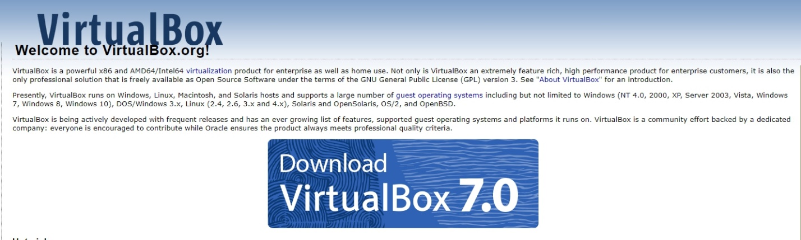

* For this example, we are using Ubuntu Server. We need to download the iso file from ubuntu.com/download/server

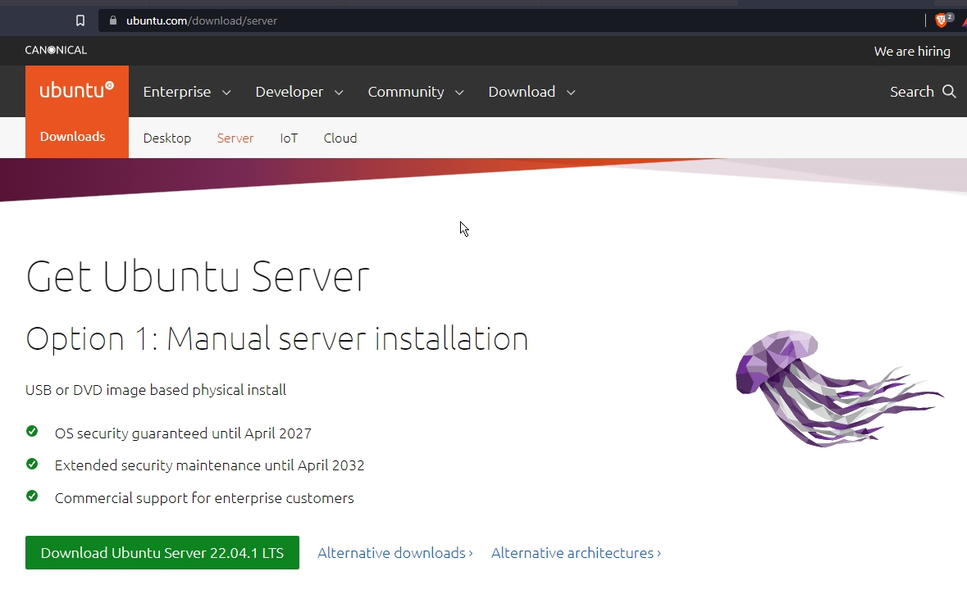

* After those two items are downloaded and installed, start Virtual Box. The main menu will look like this; from here select the ‘New’ option at the top of the user interface.

* We are now creating a new virtual machine. As stated before we are using Ubuntu Server for this example, so I chose to name this one ubuntu server 3 (I have two other ubuntu server virtual machines installed on this host. Please name the server according to your preferred naming convention. Be sure to select the correct type and version of virtual machine in the provided options.

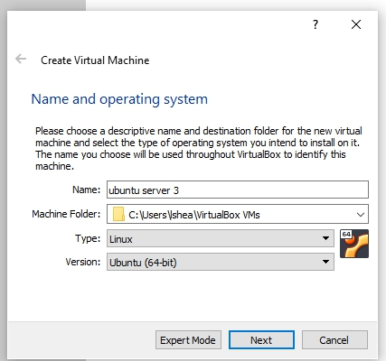

* Next you will have the option to change some settings for the virtual machine you are installing, the defaults are fine for what we are doing. But note you can allocate more memory, create a virtual hard disk (or not), select hard disk file type, and select the file location and size of the virtual machine.

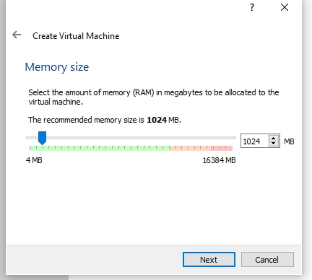

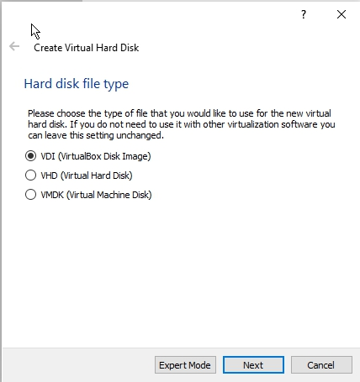

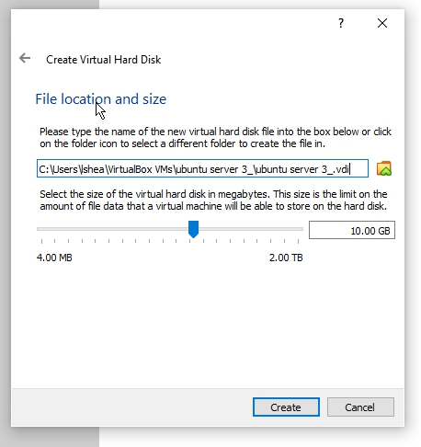

* Now that our virtual machine is installed, there are two more important steps to do before powering on the machine. First, we must add the iso file we downloaded earlier into the Optical Disk Selector. Go to settings -> Storage -> Next to ‘Controller: SATA’ select the ‘+’ sign to add an Optical Drive to the machine. Then find the path to which you installed the iso file from earlier and select the iso file to add to the machine.

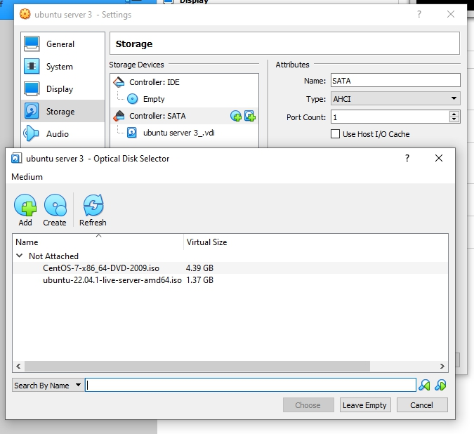

* It is also important to check the Network settings of the virtual machine. Be sure to choose the correct adapter that has internet connection. This can also be changed later but it is good to set it up correctly the first time.

